# NDUB CSE Fest Programming Contest – 2017 : Editorial

### Fidget Spinner

I didn’t expect zero submission in this problem. Well, It was an easy problem, but you must know some basic properties and formulas (cosC, area of a triangle, area of a circle sector etc.) to solve it. I’ve shown a picture to explain it easily. First you draw a red triangle like that, where you know all the side lengths as it’s given in the input. If you notice carefully, all such triangles are equilateral. So, let area=area of that triangle * 6. Then you have to find the area of the blue circle sector (You just need to find the angle of it as you already know the radius) then multiply with 3 and remove that from the previous area. Now, we’ve missed the green part in the area. Just find the angle of it then add it to the area multiplying with 3. Now, we are almost done. Just remove the area of the inner circle multiplying with 4 and answer the floor of the answer. That’s it! :D

### Re-ordering plates

As the constraints is too low. We can use a 2-D array for different piles to store plates and can use 2 map for storing plates pile number and place number. For replacing plate from one place to another we can use two loop for re-numbering all the affected plates. Then we can tell plates position from map.

### Ugly Problem (A Giveaway)

Factorize N and M, let N= f1^p1 * f2^p2 * ….. * fn^pn and M= g1^q1 * g2^q2 * ….. * gn^qn then the ans is Mmin( q1 / p1, min( q2 / p2, qn / pn ) )%10000007(you need to use bigMod here).

### Zig-zag array

This is a simple DP (Dynamic Programming) problem. The solution is that using DP approach check all possible way applying two types of operation and follow the condition to find the minimum number of operation needed to transform the array into Zig-Zag array.

### Mr. Kris Allen and the house

Observation in the problem it is said that to visit all the house with minimum cost using the limited money. So, it is not guaranteed that if he starts his journey in a specific number of house then he will visit all the house with minimum cost. That's why for finding the best path it is needed to start the journey from every house individually and searching the best path. So we can solve this problem simply using DFS. We just need to run the DFS taking the every house one by one and if every house traverse completes then we can store the min value.If it is not possible for visiting all the house then answer will be 'NO'.

### Ratul and the Himalayan Guru

Simply apply Inverse Fourier Transform on the given set of numbers.

### Atomic Counter

String searching problem. Use stack to keep track of brackets and nested elements

### Alien Coordinates

The matrix pattern is as follows:

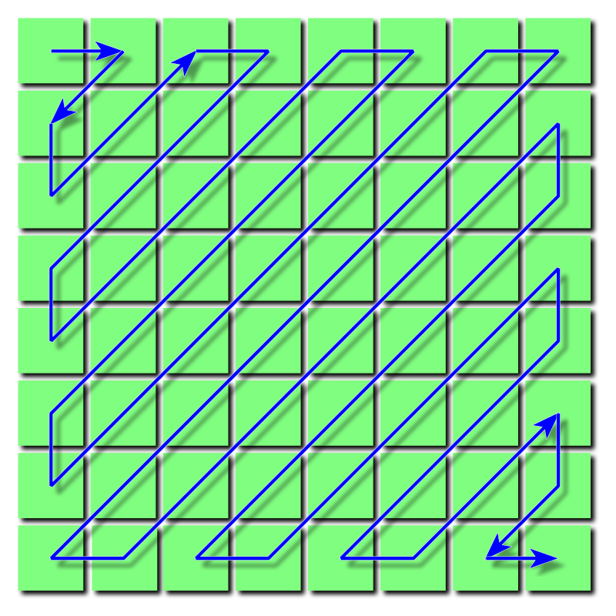

(Image taken for Wikipedia: <https://en.wikipedia.org/wiki/JPEG#/media/File:JPEG_ZigZag.svg>)